**Honor Board Accord: Fair or Foul?**

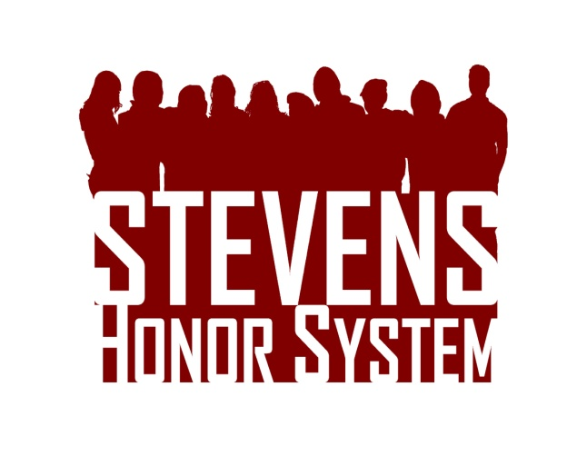Read the fake case presented to the Honor Board and determine whether a violation has occurred and what penalties should be assigned. Please support your reasoning. Visit [stevens.edu/honor](http://stevens.edu/honor) for the Honor System Bylaws and Penalty Matrix.  Drop your answers in Stevens mailbox S-1432 or email them to [honor@stevens.edu](mailto:honor@stevens.edu) by February 28th. The top response will receive a $50 Visa gift card!

A student in a European History class signs his name and the Honor Pledge before beginning his exam. During the test, he blanks on several key dates that he studied the night before. He excuses himself to go to the bathroom, at which point he looks up the forgotten information on his phone. After confidently filling in the remainder of the test, the student feels guilty for what he has done. He then hands the exam to his professor and asks her not to grade it. Should any students be found guilty of an Honor System violation? If yes, what penalty should be assigned?